FOR LANGCHAIN:
To load a loader and do chunking:
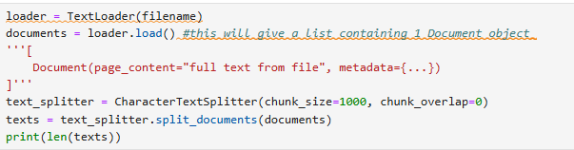
Storing the embeddings
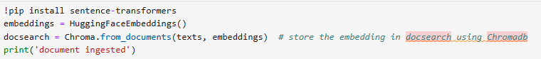
Building a rag-chain for retrieval using LangChain’s RetrievalQA class
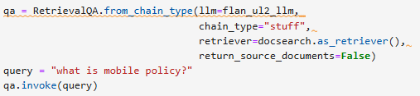
To make the LLM have memory, you introduce the ConversationBufferMemory function from LangChain.
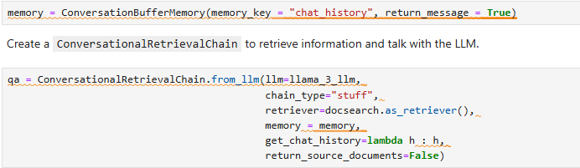
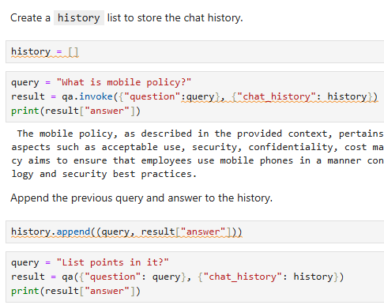 history will look like this history = [(Q1, A1), (Q2, A2), (Q2, A3)]

For Llamaindex check out project in ChatGPT. https://chatgpt.com/g/g-p-69de7c2034bc8191ad8dff50f812b00e-llamaindex/project
